Day 5 Learning
- Time travel (version history)
Time Travel (Version History) in Delta Lake is a powerful feature that allows you to access and query previous versions of your data. This is possible because Delta Lake maintains a transaction log (_delta_log) that records every change made to the table.

✅ How It Works
- Every write operation (insert, update, delete) creates a new version of the table.
- Delta Lake stores:
  - Parquet files for the actual data.
  - JSON transaction logs for metadata and versioning.
- You can query older versions by:
  - Version number (e.g., VERSION AS OF 3)
  - Timestamp (e.g., TIMESTAMP AS OF '2026-01-12')
✅ Benefits
- Auditing: Check what data looked like at a specific point in time.
- Debugging: Reproduce historical queries or fix errors.
- Rollback: Restore previous versions if something goes wrong.

- MERGE operations (upserts)
MERGE operations (Upserts) in Databricks refer to the ability to insert, update, or delete data in a Delta Lake table based on conditions—similar to SQL MERGE statements. This is extremely useful for slowly changing dimensions, data corrections, and incremental updates.
✅ What is an Upsert?
- Upsert = Update + Insert
- If a matching record exists → Update it.
- If no match exists → Insert a new record.

✅ MERGE in Delta Lake
Delta Lake supports MERGE INTO syntax, which allows you to:
- Match records between a target Delta table and a source dataset.
- Apply conditional logic for UPDATE, INSERT, or DELETE.

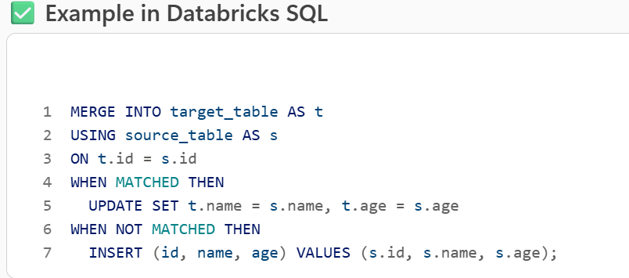

✅ Why It’s Powerful
- Handles incremental data loads without full table rewrites.
- Maintains ACID guarantees.
- Works well for streaming and batch pipelines.
✅ Real-World Use Case
- Customer Data Updates:
When new customer info arrives (e.g., updated address), you can update existing records and insert new customers in one operation.
- OPTIMIZE & ZORDER
OPTIMIZE and ZORDER in Databricks are performance tuning features for Delta Lake tables
that help improve query speed, especially for large datasets.

✅ OPTIMIZE
- What it does:
Compacts small files in a Delta table into larger files for better read performance.
- Why it’s needed:
When data is written in small batches (e.g., streaming), many tiny files are created. This slows down queries because Spark has to scan thousands of files.
- How it works:
  - Combines small Parquet files into fewer large files.
  - Reduces overhead during queries.
- Command:

OPTIMIZE delta.`/path/to/table`

- Benefit:
Faster queries, especially for large-scale analytics.

✅ ZORDER
- What it does:
Improves data skipping by co-locating related data on disk based on one or more columns.
- Why it’s needed:
When you filter on certain columns (e.g., WHERE customer_id = 123), ZORDER ensures those values are stored close together, reducing the amount of data scanned.
- How it works:
  - Sorts data files based on specified columns.
  - Creates data clustering for efficient filtering.
- Command:

OPTIMIZE delta.`/path/to/table` ZORDER BY (customer_id)

- Benefit:
Huge performance boost for queries with filter conditions.

✅ Real-World Example
- A retail company has a Delta table with billions of rows of transactions.
- Queries often filter by customer_id and date.
- Applying:

OPTIMIZE transactions ZORDER BY (customer_id, date);

reduces query time from minutes to seconds because Spark scans fewer files.

- VACUUM for cleanup

VACUUM in Databricks is a command used to clean up old files that are no longer needed in a Delta Lake table. This helps manage storage and keep your data lake efficient.

✅ Why VACUUM is Needed
- Delta Lake maintains version history for Time Travel.
- When you update or delete data, old Parquet files remain for historical queries.
- Over time, these files accumulate and consume storage.
- VACUUM removes these obsolete files after a retention period.

✅ How It Works
- By default, Delta Lake keeps old files for 7 days (configurable).
- After the retention period, you can run:

VACUUM delta.`/path/to/table` RETAIN 168 HOURS;

- RETAIN 168 HOURS = keep files for 7 days.
- This deletes files not referenced by the current Delta transaction log.

✅ Important Notes
- Retention period matters:
If you set it too low, you might break Time Travel or streaming queries.
- Safe cleanup:
VACUUM only removes files that Delta knows are no longer needed.

